ADDITIONAL INFORMATION 170.38 ACRES
6110 West State Highway 29, Burnet, TX 78611 - Burnet County

The Land – This remarkable 170.38 ± acre property is located approximately five miles west of Burnet and consists of two adjoining tracts: 88.47 ± acres acquired by the seller in 2004 and an additional 81.91 ± acres purchased in 2021. The ranch is richly wooded with an impressive variety of native trees, including post oak, live oak, elm, walnut, persimmon, cedar, and mesquite.
The southern portion of the property features gently rolling terrain with flatter areas that transition into more dramatic hills and steeper elevations toward the north, creating exceptional topography and panoramic Hill Country views. Two seasonal creeks traverse the ranch. Dog Hollow Creek, which drains an approximately 150-acre watershed, crosses the western portion of the property and serves as the primary water source for the scenic 4.2-acre lake. Rocky Hollow Creek, with an estimated 1,500-acre watershed, flows through the eastern and southern portion of the ranch, further enhancing the property's natural beauty and water resources.
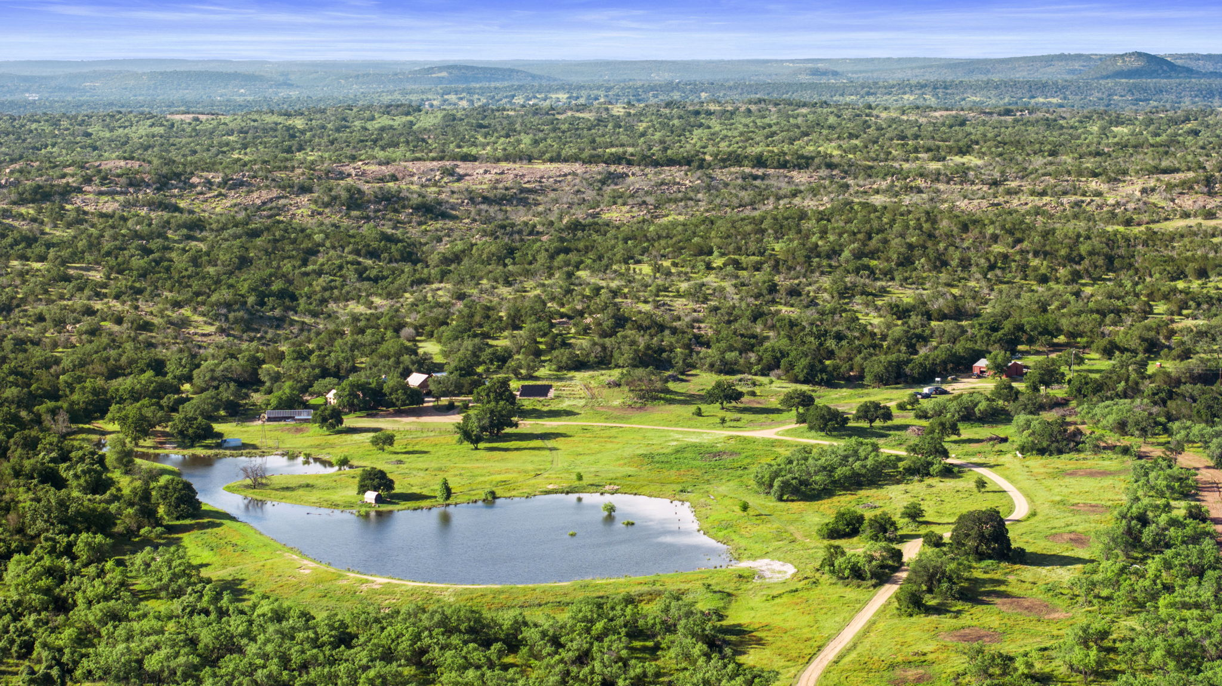

The northern portion of the property reaches elevations above 1,200 ft where the oldest rocks in Texas, part of the Llano Uplift geologic feature, are exposed. This area features unique boulders and dome formations and long-range views of the Texas Hill Country.
The Home – Built in 2009, this extraordinary residence incorporates authentic antique hand-hewn timber frames dating to the late 1700s and early 1800s, carefully relocated from the Mohawk River Valley of New York. The main house timber frame originated in Fultonville, New York, approximately 40 miles west of Albany. Heritage Restorations, based in Waco, specializes in sourcing these historic structures, meticulously disassembling each frame, and then transporting and reassembling them as part of exceptional new homes. The result is a one-of-a-kind residence that seamlessly blends centuries of craftsmanship and character with modern construction and amenities. The hand-hewn structural timbers were cut from the early American virgin hemlock forests and are much larger than any timbers available today. The Bunkhouse frame features massive 12”x 12” posts and beams and the Main House frame features top plate beams that are 45’ long. All of the timber frame joints are connected at mortise and tenon joints with wooden pegs.

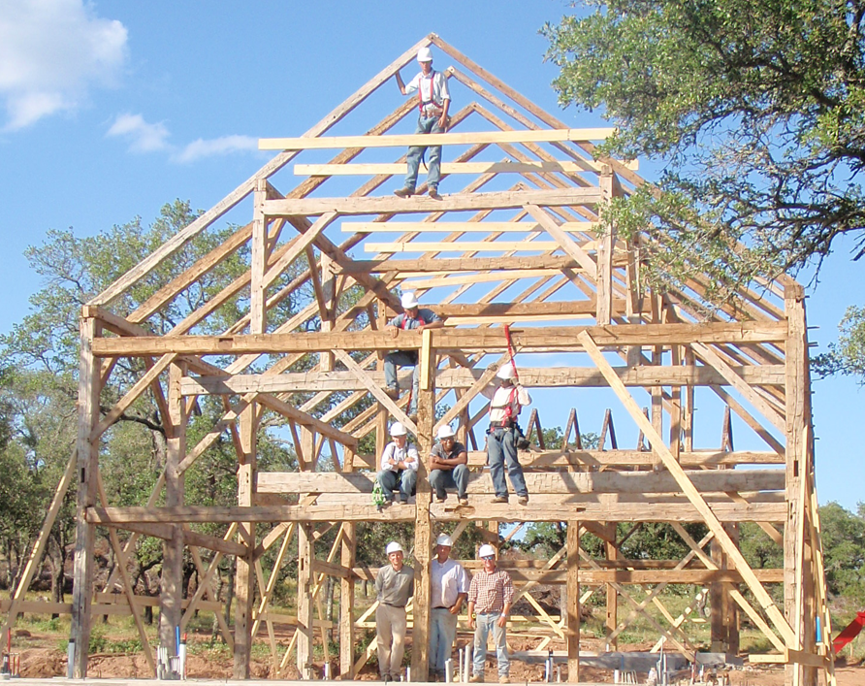

The home is enveloped in highly energy-efficient Structural Insulated Panels (SIPs), providing exceptional thermal performance and air-tight construction. Multiple zoned HVAC systems, paired with two Energy Recovery Ventilators (ERVs), maintain outstanding comfort and indoor air quality throughout the residence. The ERVs continuously replace stale indoor air with fresh outdoor air while capturing both heat and moisture from the outgoing air, significantly reducing energy loss and helping preserve a healthy, comfortable living environment year-round.
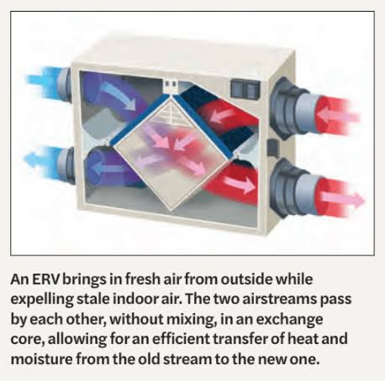
The interior of the home features mesquite flooring, milled locally, and granite and stone throughout the home. The exterior of the home is clad in Leuders limestone and eastern red cedar milled near Bee Cave, Texas.
The Carport/Shop – Was constructed in 2021 utilizing a 20 ft by 30 ft Cedar timber frame pavilion kit from Pergola Kits USA and construction of an attached 12 ft by 30 ft shop along the NW side. The structure has cedar board and batten siding and a standing seam metal roof. The interior is climate controlled with a Mitsubishi 12,000 btu heat pump mini-split HVAC.
The Rainwater System and Water Wells – A 36,000-gallon rainwater system collects water from the roofs of the Main Home, Bunkhouse Barn and associated porches (approximately 5,000 sf of roof area). Additional collection could be obtained by connecting the roof areas of the Greenhouse and Carport/Shop. Water flows by gravity to the south tank (20,000 gallons) for storage and transports via a solar pump system to the north tank (16,000 gallons) which supplies water to the home.
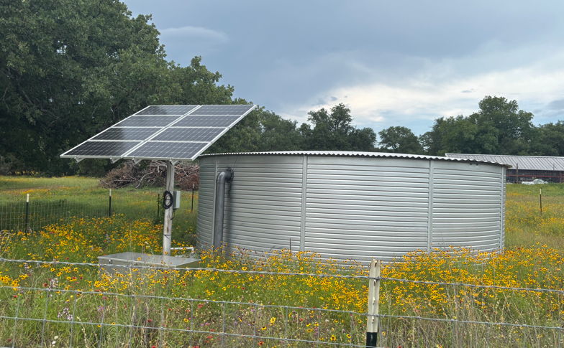
Prior to use or consumption, the water passes through 4 stage filtration and UV light treatment to remove any impurities.
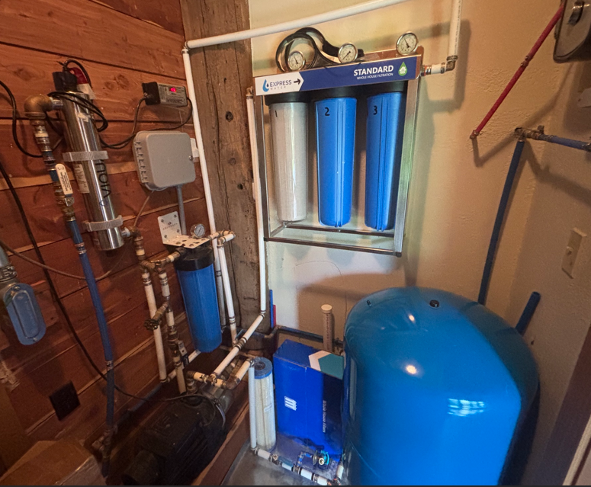This results in water quality that is far superior to water wells or municipal/city water in the area. A booster pump and pressure tank maintain pressures between 30 psi and 60 psi in the home.
Two water wells are piped together supplying water to the home hose bibs, the sprinkler system and water supplied to the Red Metal barn on the east side of the property. The east well tested at 20 gpm when drilled and the west well tested 6-8 gpm when drilled.

The Solar System – A 24 kW solar array and hybrid system was completed in December of 2025. The system consists of:
- 56 Aptos 440-watt bifacial solar panels on ground mount racks
- EG4 Gridboss MID controller (200 amp rated)
- Two EG4 Flexboss 18 (2 x 13 kW hybrid inverters, 26 kW total)
- Four EG4 indoor wall mount batteries (4 x 14.3 kW, 57.2 kW storage)
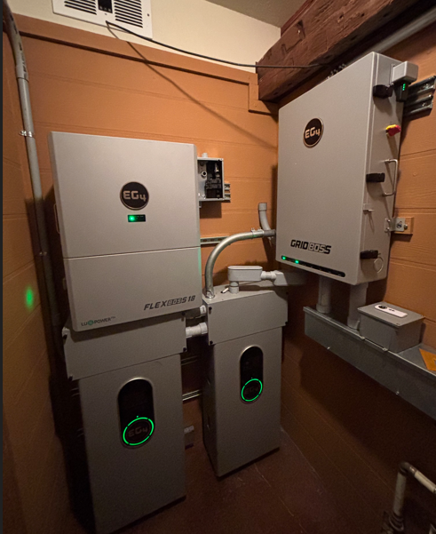
The system operates in self-consumption mode meaning it prioritizes solar and battery power over grid power. This results in most days selling back credits to the utility (PEC). The grid is always there to back up the system on cloudy days or periods where the batteries are below 40% capacity. Thus, on a typical day the grid may supply some power to the system during the night when the batteries reach 40% capacity. The batteries are typically fully recharged by noon each day and the remainder of the day the system is generating credits by exporting the excess power to the grid. The system is set not to consume from the batteries if the battery level is below 40% capacity thus preserving some capacity for a true power outage.
The resulting impact on utility bills has been impressive. The data below compares 2025 bills to 2026 bills. It should be noted that electricity usage has actually increased in 2026 due to the addition on an Electric car in early January of this year. This has resulted in an increased consumption of around 350 kWH per month over last year. Even with the addition of the electric car the electric bills have been near “zero” for the year. As the days get longer (summer) solar production will increase and offset the higher electricity consumption expected in the summer. (Note April and May had many rain days where solar production was low)

The Lake – Originally constructed in 2017 by a local contractor the dam suffered a mid-dam breach which caused an immediate loss of water and drop in water level of 6 ft during a typical flood event in the fall of 2018. It was determined that the local contractor failed to properly core trench the dam.
In 2019 the Owners rebuilt the entire length of the dam constructing a 10-15 ft wide core trench the full length of the dam down to a depth of 2 ft into the underlying native clay.
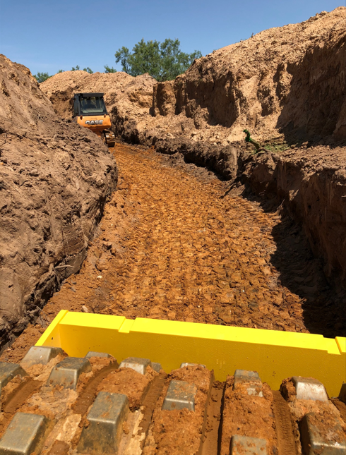
Building the core trench (July 2019)
An additional 1 ft was added to the freeboard height, and a tertiary spillway was added to relieve excess flow during a flood event. These improvements in dam construction passed the test during the 7/5/25 flood event that has been described as a 500-year flood. The 3 spillways functioned as designed and the excess water was directed downstream safely. It was estimated that 2.5 full volumes of the lake passed over the spillways during the July 2025 flood event since the pond was already standing at full level the day before the flood.
The Owners stocked baitfish (perch and minnows) in the Lake in May of 2020, and largemouth bass were stocked in September of 2020 after the baitfish were established and reproducing. Catfish were purposefully not stocked in the lake because they stir up the bottom which decreases water quality and they also compete with the largemouth bass for food resources.
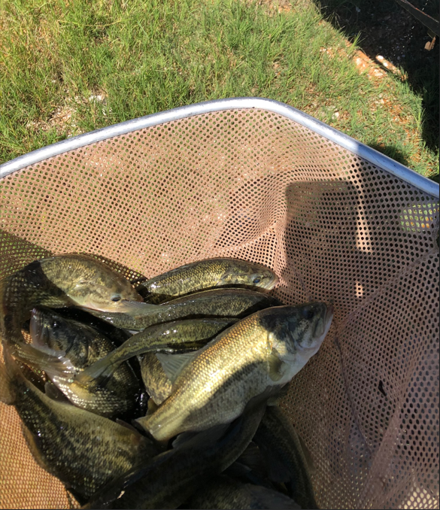
Stocking largemouth bass, September 2020.
The lake is +12 ft deep when full and covers 4.2 acres +/-. In the winter and dry periods, the Lake is typically 6-7 ft deep and covers around 2.0 acres +/-. The Lake has always maintained sufficient water levels to ensure the viability of the fish.
The Greenhouse – Constructed and completed in late 2015 the greenhouse consists of “red iron” framing, cedar siding on the north side of the structure and polycarbonate panels on the south side. The construction and orientation of the greenhouse provide for passive solar heating in the winter when sunlight extends across the full width of the greenhouse. The solid north wall of the greenhouse protects from strong north winds and cold. In the summer the light extends across 60% of the width of the greenhouse and the solid roof panels on the north half of the structure provide much needed shade during the hot summer months. Additional cooling is provided by a large evaporative cooling fan. The polycarbonate side panels are typically removed from April through October.
The greenhouse could be repurposed as an equipment or livestock barn by replacing the clear roof panels with solid panels like the north side roof.
The Red Barn (40x50 with 12x50 side shed) – The red metal barn on the east side of the property is insulated with two roll-up doors and one walk in door. 200 amp electric service is provided to the barn on a separate electric meter and service from the Main Home. There is a dedicated RV circuit at the main meter panel and a dedicated 240 volt circuit in the barn to accommodate a welding unit.

